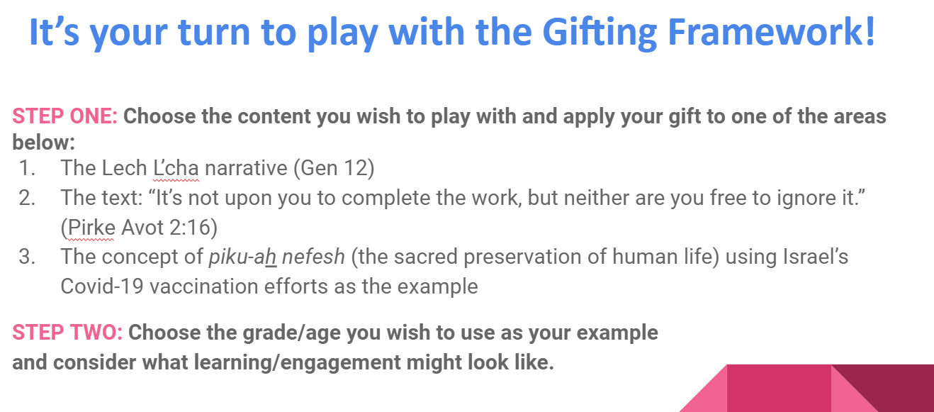

During the April ARJE webinar and the May national one, we gave participants an opportunity to play with the Gifting Framework, to see how it can offer some unique directions when curriculum planning. Below are the results of the 10 minute brainstorms from the breakout rooms. In looking at these raw notes from each group, it is up to the reader to fill in the conversation that led to these ideas.
In reflecting on the planning process in the May webinar, a participant said that those in the breakout room could do the initial brainstorming easily enough, but that it was hard to “get the airplane to fly.” Nachama responded that in “The 3+3 Project” curriculum planning, she and her team take the learning plan through multiple iterations. First, ideas are put on paper. Then, the team stops to consider how to raise the level of Jewish learning before checking for the mindset shift the group wants to engender – teachers more as learning guides than TEACHers. The document goes through other edits, including scrutiny to see if the learning activities seem to be engaging enough, put learners in the driver’s seat, age appropriate, and related to the Enduring Understanding or Essential question being explored. And THEN, the team goes back to consider each of these elements again and again. It’s an iterative, reflective process, and, if the team is lucky, the plane starts rumbling down the runway, ready to fly!

1 - Emphasis on the uniqueness, value and blessing of each individual
Breakout room 1, ARJE April
- Lech L’cha / Kindergarten
- Start with reading / hearing / telling the Lech L’cha story. Then…
- Going on a trip, need to pack a suitcase. Don’t know where you are going. What’s important to you to bring? (legos, crayons, etc) (don’t need to bring food, clothing, etc.)
  - Who do you want to bring with you?
  - If online - could go look for items to bring to show/share
  - If in person - could draw those items. If in person outdoors, find something that looks like what you want to bring (i.e. a leaf/rock)
  - What do YOU bring on this trip? (you’re funny, you like to sing, you are good at making up stories/games, etc)

Breakout room 1 May 10
- Each one of us is unique and has value. We can use these gifts to help others.
- Give each child their own jigsaw puzzle and instruct them to put their puzzle together in any way that works for them. Afterward discuss how they went about putting together the puzzle. (i/e. edges first, specific colors, etc.) Point out that everyone can tackle something differently using their own gifts and unique talents.
- Give students a group puzzle. After completion ask learners how they worked together and how each individual was needed to complete the task.

Breakout room 8 May 10
- The Lech L’cha narrative (Gen 12) for Grades 2 or 3
- Questions for students:
  - What is your place of comfort? (physical)
  - What are the things that help you on a difficult day? (emotional)
  - Leaving your “home” - going to school for the first time? Becoming an older sibling? Moving to a new house. Leaving your space of comfort.
  - What qualities does it take to “leave” with strength. To thrive!
  - How do each one of us bring a unique ability or strength to change?
  - Be a character strength (assess individual character strength) - what strengths did Avram have? Who is Avram’s father/land? L’dor v’dor sense/un

2 - Avenues for finding joy, comfort and gratitude, as well as supports for making sense of an often times chaotic world

Breakout room 2, ARJE April
Tzedakah, Social Justice
- How not to make this a lip service…
- How do you make a real plan, something that is really done…
- Active should real and realistic, doable and done… in one’s own backyard/home; looking within
EXAMPLE: how do I look at my ‘toys’ and say - I don’t need all of these to bring me joy…
How do you really make change at home

Breakout room 9, May 10
- The comfort when things are or are not completed.
  - Different sets of directions
  - Different sets of materials
  - A difference in abilities
- Fairness / Unfairness in families How to handle these feelings.
- Finding gratitude when a person’s work is not complete
- Stations with drawing tools, in which each students contributes a

3 - sense of being part of, and in reciprocal relation to, something bigger than and beyond oneself
- through the rhythms of sacred Jewish time
- through unique configurations of Jewish space (within one’s family, one’s local community, and communities beyond)
- in relation to Israel in relation with the Divine

Breakout room 3, May 10
- The text: “It’s not upon you to complete the work, but neither are you free to ignore it.” (Pirke Avot 2:16) 5th grade
- Use as bookends? As their mindset changes during the year, moving towards middle school, how do they better understand this?
- Lean into their capacity for abstract thought...being ok with there not being ONE answer...being in the grey
- Teaching about minyan...the power of one person to make minyan...once they can be included

Breakout room 10, May 10, 2021
- The text: “It’s not upon you to complete the work, but neither are you free to ignore it.” (Pirke Avot 2:16)
5th grade
- Personal experiences of feeling like you were doing all the work
- What is “the work” - ? So many meanings. Can it be done by one person alone? Does that mean you shouldn’t try?
  - What does this text mean to you? What does it make you think about how to interact with others?
  - Examples - hunger in the community - why do we do food drives? Backpack Projects
  - Social action projects, out of the building, interacting with others, kids help plan it, local projects
  - Projects run by others in congregation - can kids be involved?
  - Text study - repeated theme in Torah. Which text speaks to them the most?

4 - Richness of wisdom and memories gathered over the millennia, manifesting as diverse but interconnected Jewish perspectives, cultures and communities.

Breakout room 4, ARJE webinar
Lech L’cha- connected to Jewish history (5th-7th Grade)
- Diaspora after the 1st Temple was destroyed
- Leaving Europe
- Connected to family histories- where did your family leave from and why?
- Family tree project
- Tracking movement of generations- focusing on maps and movements
- Simulation of packing bags, what is it like to leave somewhere?

Breakout room 4 – May 10, 2021
The text: “It’s not upon you to complete the work, but neither are you free to ignore it.” (Pirke Avot 2:16)
Targeted to 6th grade and up, but could be scaled to any age
- Family stories: social justice, seder tables, immigration
- Black lives matter, civil rights movement: who was on the front lines- we are part of the chain
- Being Together program- seniors sharing stories with teens
- Delve into emotional dimension to understand the feelings in the story so they can connect to their own family and history.
- How would this open up conversation for B’nai Mitzvah families?
- Asking them what do you think the work is?
- What are you passionate about and how do you translate that into action?
- We are connected to generations before us
- Listening to people’s experiences about the Yom KIppur War.
- Continually tap into Jewish wisdom in current situations
Touch on diversity of our heritage

Breakout room 11 – May 10, 2021
Lech Lecha
- Handmade midrash
- Make your plan to help others and apply it and express gratitude that “we” can make it happen
- Leave what you know and enter something new. Tableau work – evaluate as observers
- Letters as if you were Abraham and Sarah creating an ethical will
- Personal midrash – what do you think? Compare and contrast? Fill in the blanks.

5 - tradition of questions and questioning, built on a foundation of the back-and-forth problem-solving discussions found on a page of Talmud or in midrashic stories, and actively engaged today through hugging and wrestling with contemporary dilemmas, challenge and complexity.

Breakout room 5, ARJE April
- What questions might Abraham have when God sent him on the journey.
- Sarah did not hear God and what questions might she have about the journey?
- What questions do you have for this year?
- Does everyone have the same question?

Breakout room 5, May 10
- Age group: Flexible
- Intro: Have you ever had to move? What do you take with you and what do you need in the new place? Can focus on any transitions -- schools, home/back to school
- Lech l’cha: provide age-appropriate text and student ask questions, write their own midrashim to answer (their own or each other’s, use art/acting/writing), class story game (each student tells part)
  - Resource: Make Me a Midrash from Torah Aura
- For older students, further consideration: When do you question what you’re told to do? How is it appropriate to question what you’re told to do?
- Beginning of the year, especially: Hebrew names/What does your name mean? In what ways does it represent you?
- (Sidenote: linking “It is not up to you…” to James Baldwin: “Not everything that is faced can be changed, but nothing can be changed until it is faced.”)

Breakout room 12, May 10
- 8-9th Grades- The concept of piku-ah nefesh (the sacred preservation of human life) using Israel’s Covid-19 vaccination efforts as the example
- Whoever destroys a soul, it is considered as if he destroyed an entire world. And whoever saves a life, it is considered as if he saved an entire world. — Mishnah Sanhedrin 4:9; Babylonian Talmud Tractate Sanhedrin 37a.
- Research and explore what values were used in Israel and which were prioritized. Did they fit within Jewish values? Were the right ones chosen? What values would the students prioritize and why?
- Set up a debate--students research and then debate

6 - empowerment of humanity, opening the door to generating inventive and useful responses to the challenges of our time

Breakout room 6, ARJE April
- The text: “It’s not upon you to complete the work, but neither are you free to ignore it.” (Pirke Avot 2:16)
- 6th grade: what do we do when we are faced with a challenge? What is our responsibility? We don’t need to solve all the problems--it’s too overwhelming--but we need to do our part and to teach others.
- EX. Role play, acting out a situation and see how different students respond to it
- EX. if you heard “jokes” about anti-semitism or racial slurs, how do you speak out responsibly?

Breakout room 6, May 10
“It’s not upon you to complete the work, but neither are you free to ignore it.” (Pirke Avot 2:16)
- with 5th graders
- Start with the Pirkei Avot text and talk about Noah - what if he had asked for help building the ark?
- Talk about what needs to do for self to engage in the work
- Discuss how work together at home to accomplish tasks
- Team building in class
- Figure out cause to work on (environment, inclusion, diversity, etc.)
- Work on projects:
  - First at synagogue
  - Then, local community
  - Then, county, state, the world, etc., level by level

Breakout room 13, May 10, 2021
Pikuach Nefesh - for sixth Graders
- Describe what Pikuach Nefesh is
- Show Israel’s response to Covid and the vaccine roll out
- Discussion about what is Israel’s responsibility to:
  - Jewish community
  - Arab community
  - Other communities
  - World communities
What is their circle of responsibility - what is yours?

7- passion for learning and growth, especially, but not exclusively, within a Jewish context.

Breakout room 7, ARJE webinar
The Lech L’cha narrative (Gen 12)
- Growth is about moving out of our comfort zones. Sometimes we have choices about which direction we go. Not necessarily about what happens do us, but what we choose to do with it.

Breakout room 7, May 10, 2021
“It’s not upon you to complete the work, but neither are you free to ignore it.” (Pirke Avot 2:16)
- PBL-style unit for 4th-6th grades where students are asked to explore and research an area of need in the world (hunger, poverty, environment) to determine the need, then develop a plan to contribute to the need
  - EXAMPLE: students research rates of food insecurity in their own town, then find a local organization that combats the issue; then organize an effort to support the organization
  - EXAMPLE: contact older members of the congregation to find out what they need, then connect them to resources

Breakout room 14, May 10, 2021
- Re: Pikuach Nefesh/COVID: Discussion of the Ultra-Orthodox community and how it has, by and large, not followed the COVID regulations… what should we as more liberal Jews teach about this community? Will God take care of it for us? What responsibility do we have to take care of ourselves. Certainly a question for high-school age students...

